**Computational Fluid Dynamics for Efficient Transmission Loss Prediction in Silencers**

|  |  |
| --- | --- |
| Abhijeet  M.Tech Scholar  Department of Mechanical Engineering  Millennium Institute of Technology  Bhopal, Madhya Pradesh, India | N.V. Saxena  Head of Department  Department of Mechanical Engineering  Millennium Institute of Technology  Bhopal, Madhya Pradesh, India  [nishant.mgi@gmail.com](mailto:Nishant.mgi@gmail.com) |

***Abstract:*** The study presents an analysis based on Computational Fluid Dynamics (CFD) to evaluate and optimize the acoustic performance of automotive mufflers by modifying the internal diameter of holes. Three muffler forms with hole diameters of 2 mm, 2.33 mm, and 3 mm were modelled and analysed for their effect on transmission loss (TL), internal pressure, velocity, and temperature distribution. These CFD trials have been able to demonstrate a common trend in which exhaust gas pressure and velocity are maximum at the inlet, decreasing towards the outlet due to internal flow resistance caused by perforated tubes, baffles, and acoustic absorption materials. Temperature decreases as well in this manner, with hot exhaust gases coming in contact with surface areas of cooler mufflers. The largest TL of 11.767 dB was recorded for a hole diameter of 3 mm, showing good suppression of noise while maintaining flow efficiency. Comparison of these results is closely corroborated with the reference data from Kashikar et al. (2021), which affirms the CFD approach employed here. It says that fine tuning the internal geometry of a muffler can lead to considerable exploration in noise reduction performance. CFD turns out to be an effective tool to predict acoustic behaviour and allow efficient virtual prototype development and less dependence on physical testing. The results favour the optimized design of mufflers for better performance, efficacy in complying with noise regulation standards, and improved acoustic comfort for vehicles.

**Keywords:** Computational Fluid Dynamics (CFD), Muffler Design, Transmission Loss, Acoustic Performance, Exhaust Noise Reduction, Perforated Tube Silencer, Flow and Thermal Analysis.

1. **INTRODUCTION**

Automotive engineering in general but goes very far in that aspect into noise control and silencer design using Computational Fluid Dynamics or CFD. At the beginning, the researcher focuses on multifunctional integration and the interconnectedness of mechanical, electrical, and software systems in efficient vehicle performance, safety, and efficiency enhancement. The focus in this paper is in studying important subsystems that comprise the automobile-the powertrain, braking, and steering systems-all concerning their acoustic noise control features [1]. Furthermore, all reactive, absorptive, and hybrid types of silencers along with the explanation of how they help in reducing noise and establishing efficient flow have also been discussed. Modelling Noise Control Devices using CFD will be able to simulate extremely accurately the picture of fluid flow and acoustic behaviour and reduce the use of physical prototypes and help for optimized transmission loss and internal flow characteristics and system efficiency. Hence, this holistic approach contributes to the development of quieter yet more efficient vehicles that respond to the demands of the environment and regulations [2]. In mechanical, electrical, electronics, software, and safety engineering, there are many integrated fields with which a modern vehicle relies on design, analysis, and supporting criteria to produce efficient and reliable internal combustion or alternative power sources, such as electric or hybrid.

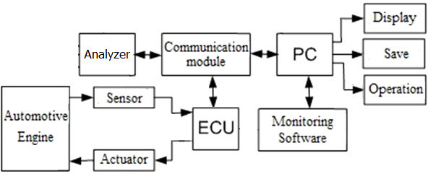

Figure 1. Hardware block diagram of detection system [3]

The automotive engine monitoring and control system, as can be seen in Figure 1, uses sensors that collect information from the engine and send it to an electronic control unit (ECU). The ECU calculates and actuates to change the performance of the engine. The setup is connected to an analyser and PC through a communication module for real-time tracking and data storage for later analysis and operational steering, which guarantee efficient engine management and corrective actions [3]. Thus, automotive engineering refers to designing and operating vehicle systems: engine, transmission, braking, fuel, electric components, air conditioning, and infotainment. It is also characterized by innovations like autonomous driving, fuel efficiency, emission reduction, and smart connectivity. And, of course, cars, jeep, buses, trucks, scooters all comprise this field by use in different transport needs for personal, commercial, and public service-use, producing a great mobility solution performance, sustainable environment, and user convenience [4][5]. The application of automotive systems and technologies involves various systems and technologies within mechanical, electrical, electronic, and software domains for enhanced performance, safety, efficiency, and user experience. Powertrain systems, applications generally include, alongside propulsion actuated primitives. Thus, an engine, usually an internal combustion engine (ICE), drives movement [6]. The transmission system varies, with power from the engine being attached to it, such that torque and speed are mechanized, depending on the current state of driving. Drive axes take the power from the differential and convey it toward the wheels, allowing them to rotate at different speeds, which is essential for both turning and traveling through uneven terrain, ensuring that the vehicle operates effectively and safely under various conditions [7].

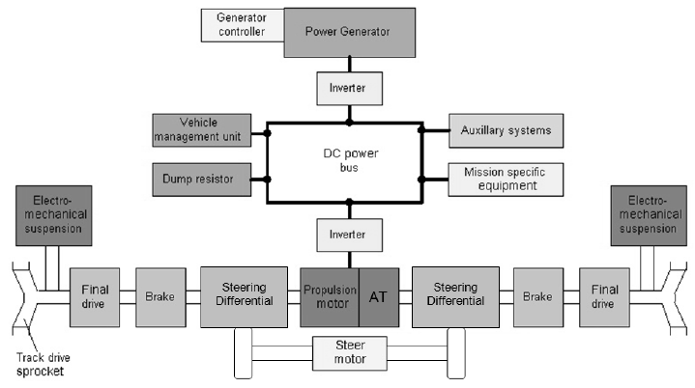

Figure 2 The powertrain system block diagram [8]

In a hybrid electric vehicle Figure 2, the drivetrain is constructed with an integrated DC power bus for conversion of energy and its distribution to different subsystems, such as the propulsion motor, vehicle management unit, and auxiliary components, thereby enhancing mobility and ride stability, particularly in the case of advanced electric tracked vehicles [8]. Conventional powertrains have undergone a transformation with the introduction of electric motors that now function in place of IC engines. This conversion allows for rumours that are very much silent and/or achieve operations with more efficiency and less emissions. A hybrid system utilizes both technologies combined to better fuel economy, while not sacrificing performance [9]. The modern powertrains also incorporate regenerative braking and energy management, which are of extreme importance concerning vehicle efficiency and environmental impact [10]. The braking systems have developed from simple mechanisms to the incorporation of ABS and Electronic Brake-force Distribution (EBD), which optimally distribute braking based on load and road conditions [11][12]. Regenerative braking with hybrid drivetrains increases energy efficiency and driving range, thus enhancing the safety and performance of the premium vehicles by a significant margin [13].

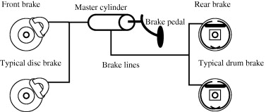

Figure 3 Typical automotive braking systems [14]

An elementary hydraulic braking system is illustrated in figure 3. The pressure is created by brake pedal action on the master cylinder, and this pressure is transmitted to the front disc brake and rear drum brakes. The system employs hydraulic pressure to balance the braking force applied, for effective and safe stopping [14]. Modern Electric Power Steering (EPS) utilizes electric motors for steering assistance and thus improves efficiency by removing hydraulic pumps. EPS works according to the speed of the vehicle, allowing light steering effort to be applied at low speed and firm control at high speed. Advanced steering systems also empower autonomy with support for lane-keeping assist and self-parking, thus ensuring safety whilst maintaining the control of the driver [15][16][17].

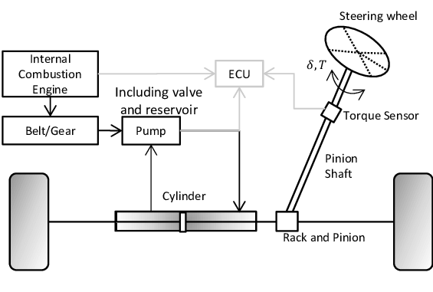

Figure 4 Simplified schematic representation of a conventional steering system [18]

The hydraulic power steering system in conjunction with an internal combustion engine is shown in Figure 4. Steering inputs are detected by a torque sensor and transmitted to the ECU, which controls the hydraulic system (pump, valve, reservoir, and cylinder) via the pinion-rack mechanism for easy steering of the wheels [18]. Mechanical noise is essentially known as the noise due to moving parts and fluid motion in systems like engines and turbines [19]. Uncontrolled noise produces discomfort and health problems and structural damage [20]. For safety, comfort, and regulatory compliance, noising is controlled, and passive devices such as silencers and absorptive materials are used to manage sound in fluid systems by engineers [22][23]. Handsy Computational Fluid Dynamics (CFD) tool is also used to analyse and predict noise behaviour as part of the strategy for reducing environmental noise in design [24].

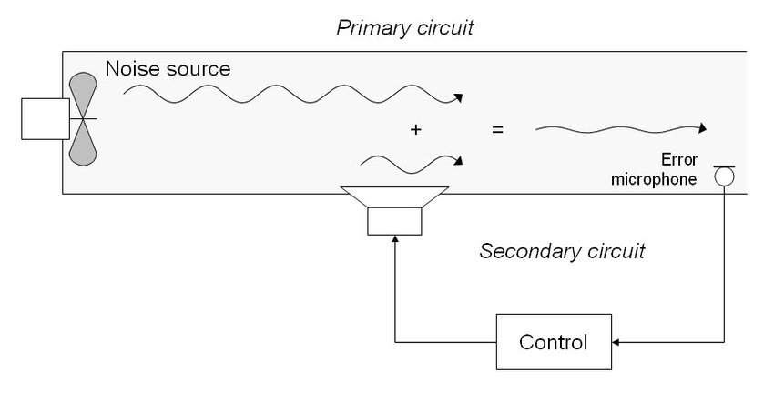

Figure 5 Conceptual view of acoustic noise suppression [25]

The ANC system is where the speaker creates a sound wave that directly counteracts the unwanted noise, thereby cancelling it as shown in Figure 5. The microphone picks up the error sound, so that the control system can adjust the signal in real time for noise reduction via destructive interference [25]. Noise control is basically important for health because it causes hearing loss, stress, and other health-related disorders if continued exposure. The noise from these industries affects worker productivity and that of communities living close to their margins as they impact more on the quality of life [26]. Regulations from OSHA, WHO, and ISO indicate noise exposure limits that are meant to protect the population and ensure compliance by industries [29][30] to encourage the process or fact of adopting noise reduction methods, such as silencers and damping materials [31].

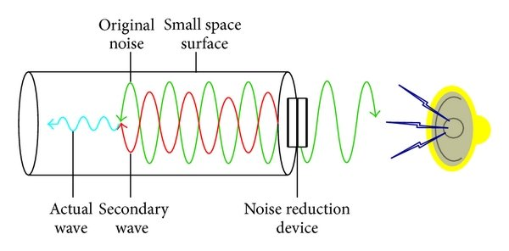

Figure 6 The basic principle of the noise reduction device [32]

An ANC system operating in a closed or tubular environment, as shown in Figure 6. Noise reduction apparatus generates a secondary wave (green), which destructively interferes with the unwanted noise (red), thus reducing the residual sound (blue) that reaches the ear and increasing sound clarity and comfort [32].

1. **Silencers**

The noise generated in fluid flow, especially that from the exhaust systems, ducting, or industrial pipelines, is suppressed by a silencer. This is achieved by limiting the transmission of sound through mechanisms of reflection, absorption, or diffusion, or some combination of these mechanisms [33]. Generally, a silencer comprises chambers, perforated tubes, and some acoustic material that dissipate sound energy. Reactive-type silencers reflect sound waves that interfere with the original sound, whereas absorptive-type silencers use porous materials to absorb sounds [34]. The hybrid designs are based on both principles for a wider spectrum of noise attenuation across various frequencies. Silencers are employed for many applications from reducing engine noise in vehicles to providing an environment of quiet airflow in HVAC systems without compromising the efficiency of fluid or gas flowing through the system [35]. Silencers reduce noise caused by turbulence, pressure fluctuations, or mechanical vibrations, without increasing back pressure and disturbing flow. They comprise features such as expansion chambers, perforated baffles, and sound absorption materials. The effectiveness of a silencer is rated by transmission loss (TL), which indicates how much sound energy got blocked or dissipated [36][37]. Silencers are required to balance acoustic performance and aerodynamic efficiency, allowing them to operate quietly without reducing the performance of the system. They are used in industries including automotive, HVAC, pneumatic equipment, and aerospace for the purposes of noise control, comfort enhancement, equipment life extension, and regulatory compliance [38][39].

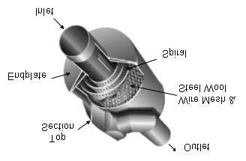

Figure 7 Diagram of an industrial silencer [40]

The figure 7 shows the internal anatomy of a muffler (or silencer) that is a device used in exhaust systems for reduction of engine noise. The exhaust gases enter through an inlet and travel through spiral tubing, surrounded by wire mesh and steel wool which absorb and dampens sound energy. Moreover, the gases will finally exit through the outlet having been passed through for a long time because their noise levels are highly reduced during the passage [40]. Silencers can be classified into three types: reactive, absorptive, and hybrid. Reactive silencers attenuate low to mid-frequency noise by reflecting sound waves using chambers and baffles, based on the principle of destructive interference. They are commonly used in automotive exhaust systems and power generation equipment [41]. Absorptive silencers reduce high-frequency noise by converting sound energy into heat through porous materials like fiberglass or mineral wool, making them suitable for HVAC systems and industrial blowers [41]. Hybrid silencers combine both reactive and absorptive principles, effectively reducing noise across a wide range of frequencies. They are ideal for complex systems, such as power plants, marine engines, and industrial facilities, where noise reduction is needed without compromising airflow or durability [42].

1. **Computational Fluid Dynamics (CFD)**

Computational Fluid Dynamics employs techniques based on numerical analysis to depict fluid flow and its related phenomena such as heat and mass transfer, solving the governing equations of fluid dynamics by discretizing the problem into a mesh of small cells with their respective volumes [48]. CFD allows engineers to analyse fluid behaviour in complex geometries. Moreover, it is capable of predicting many internal processes like pressure distribution, turbulence, and temperature gradients, which is useful in many industries such as aerospace, automotive, and energy [49]. CFD in silencer design overcomes the limitations of physical prototypes by simulating internal flow dynamics, pressure distributions, and turbulence to enhance noise attenuation, pressure drop, and resonance behaviour [51]. Advanced CFD can also simulate acoustic responses like sound propagation, reflection, and absorption, and can predict the Transmission Loss (TL) at various frequencies that can be used to optimize silencer performance [52][53]. With this synergy of analysis between fluid and acoustics, CFD helps in establishing the trade-offs between noise reduction, airflow efficiency, and pressure drop, which is particularly useful in hybrid silencers having both reactive and absorptive components [54]. Altogether, CFD reduces the design process time while increasing accuracy, performance, and compliance with acoustic standards.

1. **LITERATURE REVIEW**

**Chunhua Zeng et al. (2025) [56]** stated that previous studies have highlighted the increasing concern over noise generated by gas turbine power plants, particularly due to spatial limitations and the high noise levels associated with mechanical cooling towers. One study focused on evaluating noise control strategies based on measured noise spectra from actual projects. It compared single-side and double-side air intake configurations and found that single-side intake offered better acoustic performance and cost-effectiveness. Additionally, refined noise simulations conducted before and after implementing control measures showed strong agreement with monitored data, confirming that the optimized design effectively reduced boundary noise levels to within regulatorystandards.

**Kangjian Han et al. (2024) [59]** stated that straight through perforated tube silencers are widely used in intake and exhaust noise control, and their acoustic behaviors are influenced by the gas flow and high amplitude sound remarkably. They investigated the acoustic attenuation performance of straight through perforated tube silencers in the presence of flow and high amplitude sound, an approach based on the three-dimensional (3D) time-domain computational fluid dynamics (CFD) simulation is employed and validated by comparing predictions and measurements. Transmission loss of the straight through perforated tube silencer under pure tone and multi-tone sound excitations is predicted.

**Sushovan Chatterjee et al. (2023) [61]** stated that computational analysis of flowing exhaust gases inside a non-perforated silencer chamber of a commercially available three-cylinder inline four-stroke spark-ignition engine and in a modified perforated design was conducted and their respective levels of performance were predicted. The existing and proposed silencer designs was carried out by way of computational fluid dynamics (CFD) analysis, structural analysis and modal analysis. Modal analysis has been performed in order to compute up to six fundamental frequencies on the aforementioned structure for analyzing the response spectra for obtaining the natural frequencies at different modes of excitation.

**Rohit yadav et al. (2022) [63]** has emphasized the persistent issue of noise pollution from internal combustion engines, with exhaust systems being a major contributor. While advancements in automotive engineering have significantly improved efficiency and emissions control, noise reduction remains a key area for development. Mufflers are critical components in mitigating exhaust noise by enhancing transmission loss through design elements such as perforated tubes, sound-absorbing materials, and pipe geometry modifications. Two muffler designs were modeled and analyzed using Computational Fluid Dynamics (CFD) to evaluate their aerodynamic performance and noise reduction capabilities. This led to the identification of an optimized design offering superior performance in both noise attenuation and flow characteristics.

**Majid Kheybari et al. (2021) [70]** stated that acoustic metamaterials can control, direct, and manipulate sound waves; hence, they attract more researchers' attention in the field of automotive, aerospace, and architecture to reduce noise levels. Here, vehicle exhaust noise is investigated through finite element simulation. In this study, an improved muffler is proposed to affect the transmission loss. In the case of acoustic performance, we first designed the acoustic metamaterial baffles (AMBs) with locally resonant structures in order to reduce the noise level in the desired frequency range; a desired frequency range was targeted to be affected by tuned resonators.

**Šimon Kubas et al. (2021) [71]** stated that during each operation of the ventilation system, noise is generated, which is related to the operation of the fan during the transport of air. Attention must be paid to this noise, as the noise and depressions caused by the fan are transmitted through the pipes to the air distribution elements and thus disturb the indoor environment of the buildings. Each part of the ventilation system either absorbs or generates noise. Noise propagating and generated in pipes and fittings can be reduced in several ways, for example by dimensioning the pipes. However, noise and vibration that occur directly in the air handling unit must be eliminated in another way. Therefore, a component called a silencer is installed directly behind the air handling unit. For the correct operation of the dampers, it is necessary to monitor not only their acoustic attenuation, but also its pressure loss.

**Ujjal Kalita et al. (2021) [73]** highlighted that several studies have addressed the issue of excessive exhaust noise in four-wheeler vehicles, with the exhaust system identified as the primary source of vehicular noise. Mufflers, particularly hybrid types that combine reactive and dissipative elements, have been explored for their effectiveness across a broad frequency range. The aerodynamic and acoustic performance of the redesigned muffler was evaluated using CFD and acoustic simulations. Design and analysis were conducted using ANSYS Design Modeller, ANSYS Fluent, and COMSOL, demonstrating improved noise reduction potential of the hybrid configuration.

**L. Y. Liu et al. (2020) [74]** addressed that, compared to the linear frequency domain method, the transient Computational Fluid Dynamics (CFD) method is more effective when analyzing the effect of complex flow in the muffler on its acoustic characteristics. However, most of the existing CFD methods focus on the calculation of the transmission loss (TL) for the muffler only. The other evaluation parameters, such as noise reduction (NR), are rarely investigated. A CFD approach was developed systematically for charactering TL, NR, and transfer matrix (TM) of the muffler in the cases without and with exhaust flow. Only one mesh model with a correction pipe is needed based on two simulation runs.

**Suryawanshi et al. (2020) [75]** highlighted that noise pollution is the major drawback of I.C. engines. Automobile noise and pollution reduction have been the focus of ongoing study and development by engineers and scientists in the industry. Not only must consideration be given to noise reduction while designing the mufflers, but also to exhaust emission, back pressure, space limitations, cost incurred, etc. The mufflers have been designed and analyzed using a variety of techniques developed by researchers throughout the world. The authors have offered numerous recommendations in this regard.

**Alexandre Piccini et al. (2020) [76]** pointed out that exhaust silencer design in motorsport is a matter of establishing the best compromise between rules compliance, mass savings and engine restriction. A design methodology that acknowledges these difficulties is likely to be desirable to ensure that the best solution is always provided for the competing team. The study considered a comprehensive analysis of mass versus silencer restriction matter, based on simulated lap times to find the optimal compromises. A thorough discussion concerning the different techniques concerning passive noise control is held, establishing a widely comprehensive concept study phase.

1. **OBJECTIVE**

* Analyse the acoustic performance of the muffler system.
* Study the effect of varying hole diameters on transmission loss characteristics.
* Specify the ideal hole diameter producing maximum transmission loss.
* Experimental or simulation methods are used to validate the obtained results about transmission loss.

1. **RESEARCH METHODOLOGY**

Muffler analysis establishing design parameters, creating 3D models, running static structural analysis, and assessing performance and longevity in design. For the present study, three CAD models of varying hole diameters were created using ANSYS Design Modeler to investigate the effect of the hole diameters on the transmission loss. Mesh generation was done to tetrahedral cells with further refinement in high stress areas to yield better simulation results. Boundary conditions were applied with defined inlet and outlet to simulate realistic exhaust gas flow. CFD analysis of the model was conducted to check the simulations done for pressure, velocity, and temperature profiles using contour plots for visualization. This data gives insights into finding the transmission loss and proper assessment of the acoustic efficiency of the muffler, thus enhancing the design for noise reduction and performance.

1. **Mathematical Formulation**

Transmission loss is defined as the logarithmic ratio of the incident acoustic power to transmitted acoustic power through a structure and represents the effectiveness of a muffler in reducing the sound. It quantifies the amount of attenuation of sound energy passing through the system. It is expressed symbolically as:

$TL=10 {Log}_{10}\left(\frac{S_{i}P_{i}^{2}}{S_{O}P_{o}^{2}}\right)dB$ (4.1)

In this regard, $S_{i}$ and $S_{O}$ represent the cross-sectional areas of the muffler's inlet and outlet, while $P_{i}$ and $P_{O}$ depict the acoustic pressures at the inlet and outlet due to the incident and transmitted waves; therefore, both are very important in calculating attenuation loss, which depends on how sound energy propagates and dissipates in the muffler. If the inlet and outlet areas are identical, the area-ratio effect is nullified and the transmission loss formula depends purely on the acoustic pressure ratio.

$TL=20 {Log}_{10}\left(\frac{P_{i}}{P_{O}}\right)dB$ (4.2)

$P_{i}$ and $P_{O}$ represent almost the same acoustic pressures of the incoming and outgoing waves at the inlet and outlet of the muffler, respectively.

1. **Governing Equations**

For simulating the turbulent exhaust gas flow as seen in mufflers, the standard k-ε turbulence model is usually adopted in conjunction with continuity, momentum, and energy equations. This model is one of the most employed because it is usually robust on turbulent flow conditions. The two transport equations include that of turbulent kinetic energy, k, which is the measure for energy present in turbulence while the one for the turbulent dissipation rate ε serves to measure the energy lost and defines the time or length scale of turbulence. As per Baruah and Chatterjee (2018), the values of k and ε can be determined from the solutions of the two equations defined above regarding transport.

$\frac{δ}{δ_{t}}\left(pk\right)+\frac{δ}{{δx}_{i}}\left({pku}_{i}\right)=\frac{δ}{{δx}_{j}}\left[\left(μ+\frac{μ_{t}}{σ_{k}}\right)\frac{δ_{k}}{{δx}_{j}}\right]+G_{k}+G_{b}-ρε-Y_{M+S_{k}}$ (4.3)

$\frac{δ}{δ_{t}}(ρε)+\frac{δ}{{δx}_{i}}({ρεμ}_{i})+\frac{δ}{{δx}_{j}}\left[\left(μ+\frac{μ_{t}}{σ_{ε}}\right)\frac{δε}{{δx}_{j}}\right]+c_{1ε}\frac{ε}{k}(G_{K+G_{3ε}G_{b}})-C_{2ερ}\frac{ε^{2}}{k}+S_{ε}$ (4.4)

were,

𝐺𝑘 denotes the generation of the turbulence kinetic energy due to mean velocity gradients. 𝐺𝑏 denotes the generation of turbulence kinetic energy due to buoyancy. The model constants 𝐶1𝜀, 𝐶2𝜀, and 𝜎𝜀 have following default values. 𝐶1𝜀=1.44, 𝐶2𝜀=1.92, 𝐶𝜇=0.09, 𝜎𝑘 = 1.0 and 𝜎𝜀 = 1.3

1. **FEM Modelling of Muffler**

The Finite Element Method (FEM) is a numerical approach to break down and analyze complex systems into smaller solvable problems and most commonly used in engineering applications, such as structures, fluid flow, and heat transfer. Accuracy in measurements on output highly depends on mesh refinement, which demands adaptive meshing. For this study, 3D muffler models created using ANSYS DesignModeller for compatibility with other CAD tools such as SolidWorks were imported into the CFD analysis for performance evaluation. Dimension parameters and important simulation parameters were reported in Tables 1 and 2 while trying to achieve a systematic and efficient process of analysis.

Table 1 Parameters for simulation

|  |  |
| --- | --- |
| Case 1 | d= 2.33 mm, D=36 mm and L=300 mm |
| Case 2 | d=2 mm, D=36 mm and L=300 mm |
| Case 3 | d=3 mm, D=36 mm and L=300 mm |

Table 2 Geometrical dimensions of muffler case 1

|  |  |
| --- | --- |
| Hole diameter (mm) | 2.33 |
| Tube diameter (mm) | 36 |
| Tube length (mm) | 300 |
| Hole spacing (mm) | 4 |
| Muffler diameter (mm) | 160 |

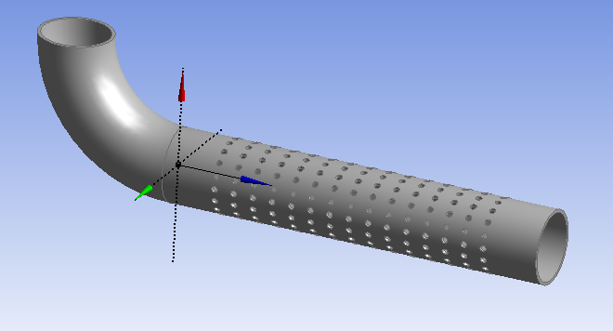

Figure 8 (a) Hole diameter

Table 3 Geometrical dimensions of muffler case 2

|  |  |
| --- | --- |
| Hole diameter (mm) | 2 |
| Tube diameter (mm) | 36 |
| Tube length (mm) | 300 |
| Hole spacing (mm) | 4 |
| Muffler diameter (mm) | 160 |

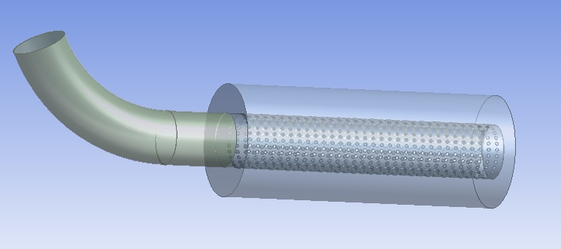

Figure 8 (b) Hole diameter

Table 4 Geometrical dimensions of muffler case 2

|  |  |
| --- | --- |
| Hole diameter (mm) | 2 |
| Tube diameter (mm) | 36 |
| Tube length (mm) | 300 |
| Hole spacing (mm) | 4 |
| Muffler diameter (mm) | 160 |

|  |  |
| --- | --- |
|  | C:\Users\Admin\Desktop\file.png |
| Figure 8 (c) Hole diameter | Figure 8 (d) Muffler cad model |

1. **Mesh Model of Connecting Rod**

Meshing is the process of breaking down complex designs or geometries into simpler components that can then be analyzed for their behavior within the overall structure. Before applying numerical methods-based engineering solutions, it is important that the proposed model possesses sufficient accuracy. In ANSYS, meshing relates a CAD model into FEA model and has each element of the mesh contributing toward the output solution. More refined mesh, however, positively affects the overall accuracy of the output; hence requires more computational time and resources. ANSYS permits default mesh sizes and control parameters under which accuracy can be balanced against efficiency. This was done using a free mesh method to optimize the amount of computer effort. The muffler CAD model was meshed with tetrahedral elements resulting in 953,423 nodes and 4,700,198 elements for detailed CFD analysis as shown in Figures 4.2a, 4.2b, and 4.2c.

|  |  |
| --- | --- |
| C:\Users\Admin\Desktop\file3.png | C:\Users\Admin\Desktop\file3.png |
| Figure 9 (a) Mesh model Case 1 | Figure 9 (b) Mesh model Case 2 |

(d= 2.33 mm, D=36 mm and L=300 fig. 4.2b, the total number of nodes is 987614 and total number of elements is 4923421. (d= 2.33 mm, D=36 mm and L=300) fig. 4.2, the total number of nodes is 976645 and total number of elements is 48787.

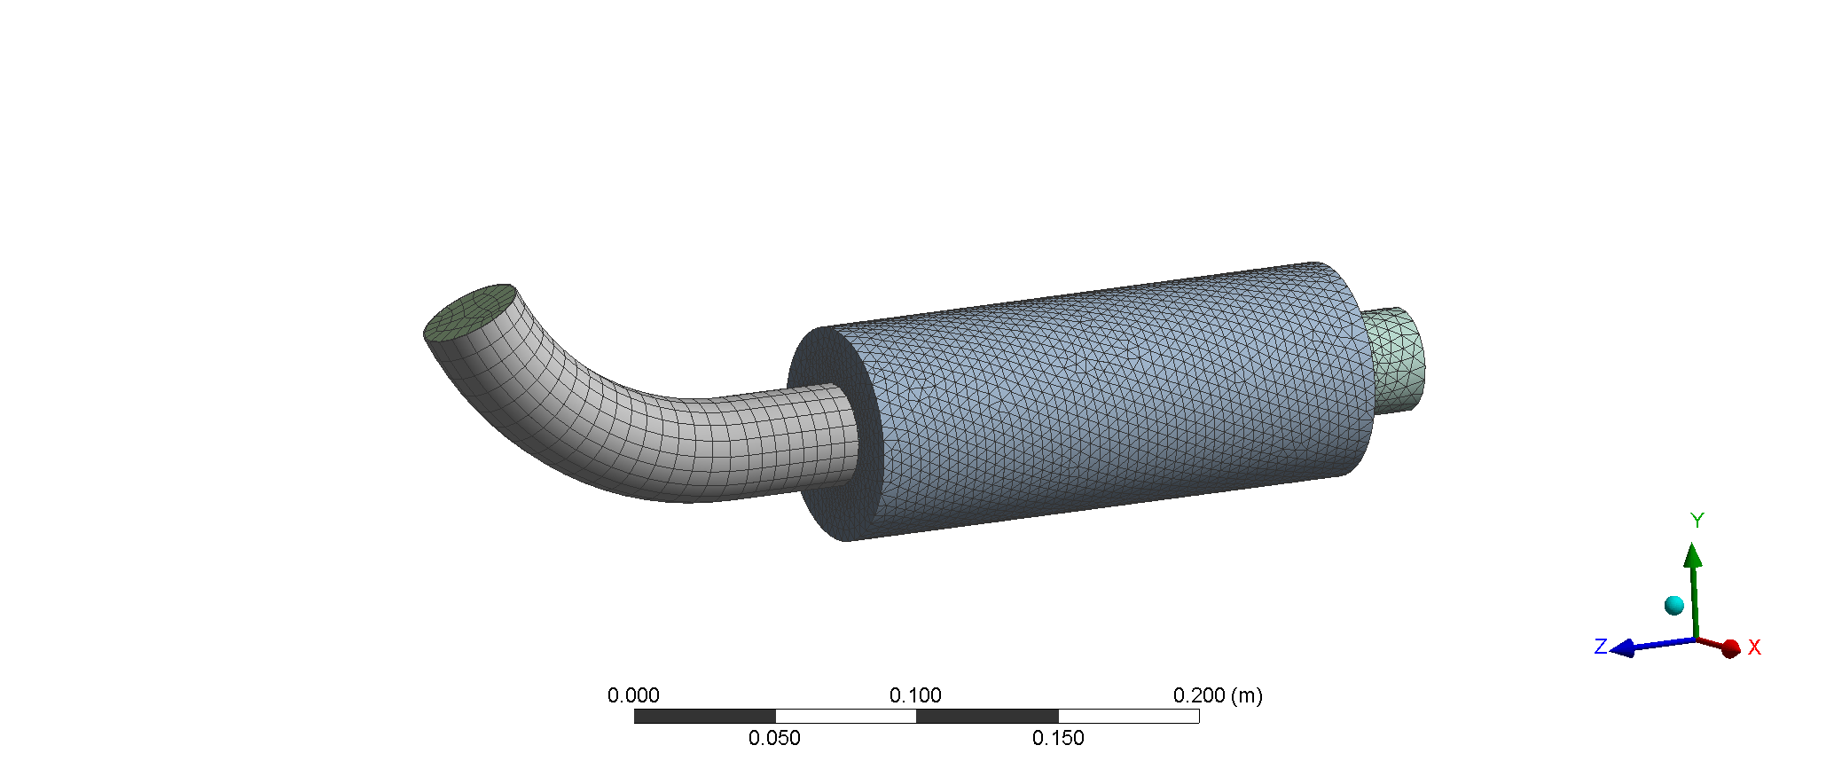

Figure 9 (c) Mesh model Case 2

(d= 3 mm, D=36 mm and L=300)

1. **Boundary Conditions**

After meshing comes the very important next stage-known as the application of boundary conditions-to faithfully represent real operating conditions during simulation. Boundary conditions specify how the muffler will interact with its environment, thereby influencing flow behaviour and pressure distribution throughout the system. Boundary conditions have been applied to the muffler model as shown in Figure 4.3 in this study. The parameter values were taken from the work of Kashikar et al. (2021) to maintain the precision and consistency of the simulation setup. The inlet pressure was set to 766.56 Pa and the inlet velocity to 47.62 m/s. These will serve as input values for simulating the exhaust gas flow through the muffler under realistic operating conditions.

**Table 5 Boundary condition used (Kashikar et. al. (2021)**

|  |  |
| --- | --- |
| Pressure | P= 766.56 Pa |
| Velocity | Vho=47.62 m/s |

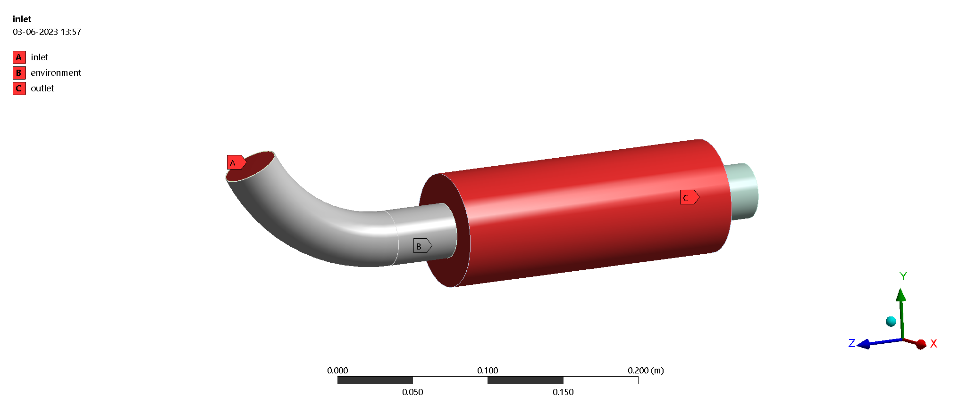

Figure 10 Boundary condition applied

1. **Validation**

The study primarily aimed at optimizing the design of mufflers by conducting the Computational Fluid Dynamics (CFD) analysis. The study intends to carry out an enhancement in the acoustic and flow performance of a muffler along with predicting transmission loss by means of CFD. This work broadly creates on the past work done by Kashikar et al. (2021), based on the "Development of muffler design and its validation" by using the Fluent solver CFD for analysis. The study will serve as the fundamental reference research work to evaluate the transmission losses and enhance the muffler efficiency under realistic flow conditions.

|  |  |
| --- | --- |
|  |  |
| (a) Air velocity (Kashikar et. al. 2021) | (b) Air velocity (present result) |
|  |  |
| (c) Pressure (Kashikar et. al. 2021) | (d) Pressure (present result) |

|  |
| --- |
| Figure 11 Results validation |

The static pressure field and the air velocity field of the muffler were compared and validated under the same boundary conditions, per the above observations. Results from this study are slightly lower than those reported by Kashikar et al. (2021). Notwithstanding this small offset, the general trend and behaviour still held well; hence, a high level of agreement was achieved. Therefore, it can be concluded that the CFD analysis conducted by using CFX solver establishes a validation of the results from the base study and adds credibility to the current simulation approach.

Table 6 Results validation

|  |  |
| --- | --- |
| **Present study** | **Kashikar et. al. 2021** |
| Air velocity=39.97 m/s | Air velocity=47.62 m/s |
| Pressure= 710.1 Pa | Pressure= 766.56 Pa |

1. **Results And Discussion**

This study presents three hypothetical Cross cases to determine and compare the transmission loss (TL) of a muffler through CFD analysis. In Case 1, parameters from Kashikar et al. (2021) hole diameter (d) = 2.33 mm, outer diameter (D) = 36 mm and length (L) = 300 mm giving a calculated TL of 10.572 dB. Case 2 reduced the hole diameter to 2 mm, while Case 3 increased it to 3 mm, both maintaining the same outer diameter and length. The transmission losses for all cases were compared against the base case in order to study the effect of changing hole dimensions on performance of muffler.

1. **Transmission Losses for Case 1 (d=2.33 mm, D=36 mm and L=300)**

The results of pressure distribution show that the pressure is at maximum at the entrance of the muffler for exhaust gases decreasing toward the outlet of the muffler. The change in pressure is due to energy losses through friction, turbulence, and flow resistance within a muffler. Such a typical drop in pressure through a muffler system indicates how effective they are in dissipating exhaust energy. This is visually illustrated in figures 5.1 and 5.2, where pressure decreases from inlet to outlet. The entry of exhaust gases brings with them high pressures being the result from the combustion process in the engine. This occurs as they pass through the perforated holes intended to create resistance and change the flow direction, causing a pressure reduction from the effect of resistance and sound-absorbing materials. This enables gradual pressure reduction as gases flow through the muffler towards the outlet, as summarized in Table 7.

|  |  |
| --- | --- |
|  |  |
| Figure 12 Pressure contour for case 1 | Figure 13 Pressure contour at outlet for case 1 |

Table 7 Summary of pressure results

|  |  |  |
| --- | --- | --- |
| Case | Inlet pressure (pi) | Out pressure (Po) |
| 1 | 843.10 | 267.56 |

|  |  |
| --- | --- |
|  |  |

|  |  |
| --- | --- |
| Figure 14 Velocity Contour for Case 1 | Figure 15 Temperature Contour for Case 1 |

The high velocity of exhaust gas at the entrance of the muffler is due to excessive momentum of the exhaust gases coming out of the engine. As gases move through the holes and the expansion chamber, their velocity decreases because the expansion chamber increases the available volume for the same mass of gas, thereby decreasing the velocity. The temperature distribution inside the muffler in Figure 5.4 explains the variations in gas temperature as the gas proceeds through different components. The gas temperature at the entrance is high because the exhaust gases attain this temperature during combustion in the engine. However, in their flow through the perforated tubes or pipes, gases lose heat to the muffler walls, lowering their temperature.

1. **Transmission Losses for Case 2 (d=2 mm, D=36 mm and L=300)**

The pressure distribution within the muffler reveals a gradual drop from the inlet to the outlet, as depicted in Figures 5.5 and 5.6. This is due to the high-pressure exhaust gases losing energy through perforated holes and narrow passages and changing their direction, which causes resistance, friction, and turbulence within the muffler. Some of this energy is also absorbed by sound-deadening materials that help in further reducing the pressure. This gradual pressure fall thus helps in suppressing the noise and maintaining a smoother exhaust flow similar to the simulation results.

|  |  |
| --- | --- |
|  |  |
| Figure 15 Pressure Contour for Case 2 | Figure 17 Pressure Contour at Outlet for Case 2 |

The pressure within the muffler decreases progressively at the inlet to the outlet, due to loss of energy from internal components such as perforated tubes and baffles, in conjunction with sound-absorbing materials which attenuate the energy of the exhaust gases. This pressure drop has been mentioned in Table 8. Also, the velocity contour indicates how gas velocity differs within the muffler. Initially high at the entrance due to engine momentum, gas velocity decreases as the gas passes into the expansion chamber through the perforated holes. This distribution of velocity depends on the muffler design as demonstrated in Figure 18.

Table 8 Summary of Pressure Results

|  |  |  |
| --- | --- | --- |
| Case | Inlet pressure (pi) | Out pressure (Po) |
| 2 | 973.1 k.pa | 284.31 k.pa |

The temperature contour demonstrates the variation in temperature of exhaust gases inside the muffler. The highest temperature is registered at the inlet due to the combustion process, followed by a gradual drop in temperature through the perforated tubes as the gases interact with the cooler internal surfaces of the muffler. This cooling enhances thermal efficiency and life expectancy of components, as demonstrated in Figure 19.

|  |  |
| --- | --- |
|  |  |
| Figure 18 Velocity Contour for Case 2 | Figure 19 Temperature Contour for Case 2 |

1. **Transmission Losses for Case 3 (d=3 mm, D=36 mm and L=300)**

The exhaust gas pressure maxima that are seen at the entrance of the muffler and subsequently decline toward the outlet are related to a pressure gradient. The decrease is caused due to a joining of high-pressure gases after combustion with several internal parts such as perforated tubes, chambers, as well as sound-absorbing material in the muffler. Such parts will create resistance and redirect flow, which would soften the pressure loss. The general principle used by both the flow resistance and acoustic absorption in a muffler reduces the pressure and noise level throughout the muffler.

|  |  |
| --- | --- |
|  |  |
| Figure 20 Pressure Contour for Case 3 | Figure 21 Pressure Contour at outlet for Case 3 |

As displayed in Table 9, the gradual reduction of pressure inside the muffler occurs when the exhaust gases pass through perforated holes. This reduction is due to certain resistances offered by its internal components and sound-absorbing materials. The contour of gas velocity, given in Figure 22, describes the variation of gas velocity through the muffler from a high value at the inlet, due to engine momentum, to low values after passing through the perforations and entering the expansion chamber, where there is a high increase in volume and reduced velocity.

|  |  |
| --- | --- |
|  |  |

|  |  |
| --- | --- |
| Figure 22 Velocity Contour for Case 3 | Figure 23 Temperature Contour for Case 3 |

As seen in Figure 23, the temperature contour of the muffler explains how the exhaust gas temperature varies throughout a journey in the different components. The hot temperature at the inlet from the preliminary combustion gradually drops through the perforated tubes and contact with the muffler walls, which act as heat sinks. Furthermore, pressure values at the inlet and outlet are generated through CFD analysis, and then the transmission losses are computed using a suitable relationship. According to Table 10, the transmission loss (TL) value has been found the same for Case 1, which is 9.969 dB, Case 2, which is 10.687 dB, and Case 3, which is 11.767 dB. The maximum TL is documented at d = 3 mm, D = 36 mm, and L = 300 mm. This result is deviated by 11.30% from the findings of Kashikar et al. (2021). In addition, TL obtained in Case 1 (9.969 dB) showed 5.7% deviation from TL reference value as reported in same reference study. But overall trend is based on results that still remain consistent and variation is evident within limits. Therefore, the results of the current study can rightly be said to be in good agreement with those of Kashikar et al. (2021), validating the effectiveness of CFD analysis and design method applied in the present study shows in figure 24.

Table 10 Summary of Results

|  |  |  |
| --- | --- | --- |
| **S. N** | **Transmission losses (TL) (dB) from present study** | **Transmission losses (TL) (dB) from the study of Kashikar et al. (2021)** |
| Case 1(d=2.33 mm, D=36 mm and L=300) | 9.969 | 10.572 |
| Case 2(d=2 mm, D=36 mm and L=300) | 10.687 |  |
| Case 3(d=3 mm, D=36 mm and L=300) | 11.767 |  |

Figure 24 Variation of Transmission Loss

1. **CONCLUSION**

In this study, the efficacy of Computational Fluid Dynamics (CFD) in predicting and optimizing the acoustic and flow performance of automotive mufflers has been demonstrated effectively. The pressure, velocity, and temperature contours were analysed at mufflers for varying internal hole diameters, and it was observed that there is a pressure and velocity reduction in the exhaust gases, which tends to be more from the inlet to the outlet due to the internal components and interaction with sound-absorbing materials. This reduction is essential for effective noise suppression and thermal efficiency. Among the three tested cases, case number 3 (hole diameter = 3 mm) showed the highest transmission loss (TL) of 11.767 dB more than case 1 and case 2. The results of this study also correlate with those of the benchmark study by Kashikar et al. (2021), albeit some deviations are reported within the acceptable limits. This thus confirms the CFD approach and design methodology used in this current studies. The findings indicate the success of varying internal geometries; more so hole diameters, in performance improvement in muffling. CFD is indeed a strong virtual prototyping tool that engineers can use in minimising noise, cutting design time, and optimally configuring mufflers for acoustic performance and flow efficiency.

**Conflict of Interest:** The corresponding author, on behalf of second author, confirms that there are no conflicts of interest to disclose.

**Copyright:** © 2025 Abhijeet , N.V. Saxena Author(s) retain the copyright of their original work while granting publication rights to the journal.

**License:** This work is licensed under a Creative Commons Attribution 4.0 International License, allowing others to distribute, remix, adapt, and build upon it, even for commercial purposes, with proper attribution. Author(s) are also permitted to post their work in institutional repositories, social media, or other platforms.

**Reference**

1. Yan, L., & Xu, H. (2025). Lightweight composite materials in automotive engineering: State-of-the-art and future trends. *Alexandria Engineering Journal*, *118*, 1-10. <https://doi.org/10.1016/j.aej.2024.12.002>
2. Wang, P.E., Ghassemi-Armaki, H., Pour, M. *et al.* Applicable and generalizable machine learning for intelligent welding in automotive manufacturing. *Weld World* (2025). <https://doi.org/10.1007/s40194-025-01951-5>
3. CUI, Hongwei. (2014). Design and Research on Automotive Controller Area Network Bus Analyzer. Sensors and Transducers. 166. 91-95.
4. Blaga, P., Cășeriu, B. M., Bucur, B., & Veres, C. (2025). A Comprehensive Review of Ergonomics and Human Factors Engineering for Enhancing Comfort and Efficiency in Transport Systems. *Systems*, *13*(1), 35. <https://doi.org/10.3390/systems13010035>
5. Chau, K. T., Chan, C. C., Niu, S., Liu, W., & Liu, T. (2025). Graduate Degree in Electric Vehicles—A Timely Programme for Modern Society. *World Electric Vehicle Journal*, *16*(1), 31. <https://doi.org/10.3390/wevj16010031>
6. Dannier, A., Brando, G., Ribera, M., & Spina, I. (2025). Li-Ion Batteries for Electric Vehicle Applications: An Overview of Accurate State of Charge/State of Health Estimation Methods. *Energies*, *18*(4), 786. <https://doi.org/10.3390/en18040786>
7. Yan, L., & Xu, H. (2025). Lightweight composite materials in automotive engineering: State-of-the-art and future trends. *Alexandria Engineering Journal*, *118*, 1-10. <https://doi.org/10.3390/en18040786>
8. Galvagno, Enrico & Velardocchia, Mauro & Rondinelli, Enzo. (2012). Electro-Mechanical Transmission modelling for series-hybrid tracked tanks. International Journal of Heavy Vehicle Systems. 19. 256-280. 10.1504/IJHVS.2012.047916.
9. Morales Matamoros, O., Takeo Nava, J. G., Moreno Escobar, J. J., & Ceballos Chávez, B. A. (2025). Artificial Intelligence for Quality Defects in the Automotive Industry: A Systemic Review. *Sensors*, *25*(5), 1288. <https://doi.org/10.3390/s25051288>
10. Hua, L., Tang, J., & Zhu, G. (2025, January). A Survey of Vehicle System and Energy Models. In *Actuators* (Vol. 14, No. 1, p. 10). MDPI. <https://doi.org/10.3390/act14010010>
11. Khatory, S., Chafouk, H., & Mellouli, E. M. (2025). Enhanced Anti-Lock Braking System Performance: A Comparative Study of Adaptive Terminal Sliding Mode Control Approaches. *Vehicles*, *7*(1), 14. <https://doi.org/10.3390/vehicles7010014>
12. Zhang, C., Wang, X., Jiao, F. *et al.* Advances in the processing of ceramic matrix composites: a review. *Int J Adv Manuf Technol* (2025). <https://doi.org/10.1007/s00170-025-15430-0>
13. Pointner-Gabriel, L., Voelkel, K., & Stahl, K. (2025). Drag Losses of Wet Brakes and Clutches—A Scoping Review. *Lubricants*, *13*(1), 27. <https://doi.org/10.3390/lubricants13010027>
14. El-Garhy, Ahmed & El-Sheikh, Gamal & El-Saify, Mohamed. (2013). Fuzzy Life-Extending Control of Anti-Lock Braking System. Ain Shams Engineering Journal. 4. 735–751. 10.1016/j.asej.2012.12.003.
15. Yan, L., & Xu, H. (2025). Lightweight composite materials in automotive engineering: State-of-the-art and future trends. *Alexandria Engineering Journal*, *118*, 1-10. <https://doi.org/10.22075/macs.2024.32547.1589>
16. Khan, F., Hossain, N., Mim, J. J., Rahman, S. M., Iqbal, M. J., Billah, M., & Chowdhury, M. A. (2024). Advances of composite materials in automobile applications–A review. *Journal of Engineering Research*. <https://doi.org/10.1016/j.jer.2024.02.017>
17. Perdana, M. A. P., Budiman, A. C., Ristiana, R., Muharam, A., Ismail, K., Kurnia, M. R., ... & Hapid, A. (2024). Control Strategies for Steer-By-Wire Systems: An Overview. *Technologies*, *13*(1), 6. <https://doi.org/10.3390/technologies13010006>
18. Silvas, Emilia & Backx, Eric & Hofman, Theo & Voets, Henk & Steinbuch, M.. (2014). Design of Power Steering Systems for Heavy-Duty Long-Haul Vehicles.
19. de Hoz, L., & McAlpine, D. (2024). Noises on—How the Brain Deals with Acoustic Noise. *Biology*, *13*(7), 501. <https://doi.org/10.3390/biology13070501>
20. Oliveira, M. A., & António, J. (2024). Animal-based waste for building acoustic applications: A review. *Journal of Building Engineering*, *84*, 108430. <https://doi.org/10.1016/j.jobe.2023.108430>
21. Fa, L., Yang, H., Fa, Y. et al. Progress in acoustic measurements and geoacoustic applications. AAPPS Bull. 34, 23 (2024). <https://doi.org/10.1007/s43673-024-00127-5>
22. Escalona, M. M., Campos-Roca, Y., & Sánchez, C. J. P. (2024). Enhancing noise robustness of automatic Parkinson’s disease detection in diadochokinesis tests using multicondition training. *Expert Systems with Applications*, 125401. <https://doi.org/10.1016/j.eswa.2024.125401>
23. Casarella, A., Notaro, A., Laria, C., Serra, N., Genovese, E., Malesci, R., ... & Fetoni, A. R. (2024). State-of-the-Art on the Impact of Bimodal Acoustic Stimulation on Speech Perception in Noise in Adults: A Systematic Review. *Audiology Research*, *14*(5), 914-927. <https://doi.org/10.3390/audiolres14050077>
24. Sánchez-Peña, Ricardo & Cugueró-Escofet, Miquel & Masip-Alvarez, Albert & Quevedo, Joseba & Puig, Vicenç. (2008). Robust identification and feedback design: An active noise control case study. Control Engineering Practice. 16. 1265-1274. 10.1016/j.conengprac.2008.02.004.
25. Tao, Y., Ren, M., Zhang, H., & Peijs, T. (2021). Recent progress in acoustic materials and noise control strategies–A review. *Applied Materials Today*, *24*, 101141. <https://doi.org/10.1016/j.apmt.2021.101141>
26. Hahad, O., Jimenez, M. T. B., Kuntic, M., Frenis, K., Steven, S., Daiber, A., & Muenzel, T. (2022). Cerebral consequences of environmental noise exposure. *Environment international*, *165*, 107306. <https://doi.org/10.1016/j.envint.2022.107306>
27. Hua, J., & Mankbadi, R. R. (2024). Prediction and Control of Broadband Noise Associated with Advanced Air Mobility—A Review. *Applied Sciences*, *14*(18), 8455. <https://doi.org/10.3390/app14188455>
28. Chen, KH., Su, SB. & Chen, KT. An overview of occupational noise-induced hearing loss among workers: epidemiology, pathogenesis, and preventive measures. Environ Health Prev Med 25, 65 (2020). <https://doi.org/10.1186/s12199-020-00906-0>
29. Wang, Chao & Gao, Haiyang & Yu, Liyao & Yu, Tiantian & Yan, Wenhui & Xue, Qiumeng. (2016). Portable Low-Frequency Noise Reduction Device for Both Small Open and Closed Spaces. Shock and Vibration. 2016. 1-11. 10.1155/2016/6241935.
30. Zhang, Y., See, Y. X., Tergaonkar, V., & Fullwood, M. J. (2022). Long-distance repression by human silencers: chromatin interactions and phase separation in silencers. *Cells*, *11*(9), 1560. <https://doi.org/10.3390/cells11091560>
31. Piña-Iturbe, A., Suazo, I. D., Hoppe-Elsholz, G., Ulloa-Allendes, D., González, P. A., Kalergis, A. M., & Bueno, S. M. (2020). Horizontally acquired homologs of xenogeneic silencers: modulators of gene expression encoded by plasmids, phages and genomic islands. *Genes*, *11*(2), 142. <https://doi.org/10.3390/genes11020142>
32. Hough, A., Wearden, J., de Almeida, K. *et al.* Review of Transthyretin Silencers, Stabilizers, and Fibril Removal Agents in the Treatment of Transthyretin Cardiac Amyloid. *Curr Cardiol Rep* **22**, 106 (2020). <https://doi.org/10.1007/s11886-020-01374-2>.
33. Pang, B., van Weerd, J. H., Hamoen, F. L., & Snyder, M. P. (2023). Identification of non-coding silencer elements and their regulation of gene expression. *Nature Reviews Molecular Cell Biology*, *24*(6), 383-395. <https://doi.org/10.1038/s41580-022-00549-9>
34. Iñiguez-Muñoz, S., Llinàs-Arias, P., Ensenyat-Mendez, M. *et al.* Hidden secrets of the cancer genome: unlocking the impact of non-coding mutations in gene regulatory elements. *Cell. Mol. Life Sci.* **81**, 274 (2024). <https://doi.org/10.1007/s00018-024-05314-z>
35. Jiao, J., & Tian, C. F. (2020). Ancestral zinc-finger bearing protein MucR in alpha-proteobacteria: a novel xenogeneic silencer?. *Computational and Structural Biotechnology Journal*, *18*, 3623-3631. <https://doi.org/10.1016/j.csbj.2020.11.028>
36. Hough, A., Wearden, J., de Almeida, K. *et al.* Review of Transthyretin Silencers, Stabilizers, and Fibril Removal Agents in the Treatment of Transthyretin Cardiac Amyloid. *Curr Cardiol Rep* **22**, 106 (2020). https://doi.org/10.1007/s11886-020-01374-2
37. Wong, Lee & Wang, Gary & Strong, Doug. (2004). A New Design for Production (DFP) Methodology with Two Case Studies. Concurrent Engineering: R&A. 12. 263-273. 10.1177/1063293X04046614.
38. Kulkarni, M., & Jadhav, S. (2023). Acoustic analysis of single expansion chamber reactive muffler-A critical review. *International Journal of Scientific Engineering and Research*, *11*(1), 37-42.
39. Sienkiewicz, N., Dominic, M., & Parameswaranpillai, J. (2022). Natural fillers as potential modifying agents for epoxy composition: A review. *Polymers*, *14*(2), 265. <https://doi.org/10.3390/polym14020265>
40. (CFD) applications in agricultural building modelling: Research, applications and challenges. *Computers and Electronics in Agriculture*, *201*, 107277. <https://doi.org/10.1016/j.compag.2022.107277>
41. Tsang, T. W., Mui, K. W., & Wong, L. T. (2023). Computational Fluid Dynamics (CFD) studies on airborne transmission in hospitals: A review on the research approaches and the challenges. *Journal of Building Engineering*, *63*, 105533. <https://doi.org/10.1016/j.jobe.2022.105533>
42. Shen, R., Jiao, Z., Parker, T., Sun, Y., & Wang, Q. (2020). Recent application of Computational Fluid Dynamics (CFD) in process safety and loss prevention: A review. *Journal of Loss Prevention in the Process Industries*, *67*, 104252. <https://doi.org/10.1016/j.jlp.2020.104252>
43. Yi, H., Kim, M., Lee, D., & Park, J. (2022). Applications of computational fluid dynamics for mine ventilation in mineral development. *Energies*, *15*(22), 8405. <https://doi.org/10.3390/en15228405>
44. Bugaru, M., & Vasile, C. M. (2024). Recent Developments in Using a Modified Transfer Matrix Method for an Automotive Exhaust Muffler Design Based on Computation Fluid Dynamics in 3D. *Computation*, *12*(4), 73. <https://doi.org/10.3390/computation12040073>
45. Haghighi, M., Mirzaei, R., Putra, A., & Taban, E. (2024). A comprehensive review of advances and techniques in muffler acoustics and design. *International Journal of Environmental Science and Technology*, *21*(13), 8695-8716. <https://doi.org/10.1007/s13762-024-05686-6>
46. Stan, C., Năstase, I., Bode, F., & Calotă, R. (2024). Smoke and Hot Gas Removal in Underground Parking Through Computational Fluid Dynamics: A State of the Art and Future Challenges. *Fire*, *7*(11), 375. <https://doi.org/10.3390/fire7110375>
47. Zeng, C., Chen, Z., & He, S. (2025). Research on Noise Control Optimization of Mechanical Cooling Tower in Gas Turbine Power Plant Based on Sound Source Monitoring and Noise Simulation. In E3S Web of Conferences (Vol. 615, p. 01001). EDP Sciences. <https://doi.org/10.1051/e3sconf/202561501001>
48. Han, K., & Ji, Z. (2024). Nonlinear Acoustic Behavior Prediction and Analysis of Straight Through Perforated Tube Silencer With Flow. International Journal of Acoustics & Vibration, 297(1). <https://doi.org/10.20855/ijav.2024.29.12018>
49. Chatterjee, S., & Bandara, P. (2023). Computational analysis on flow induced stress and acoustic vibration in a proposed silencer design for a three-cylinder in-line four-stroke spark ignition engine. International Journal of Vehicle Noise and Vibration, 19(1-2), 98-116. <https://doi.org/10.1504/IJVNV.2023.130251>
50. YADAV, R. (2022). MODELLING AND ANALYSIS OF DIESEL ENGINE MUFFLER USING CFD (Doctoral dissertation, Andhra University). <http://www.joics.org/>
51. Kheybari, M., & Ebrahimi-Nejad, S. (2021). Dual-target-frequency-range stop-band acoustic metamaterial muffler: acoustic and CFD approach. Engineering Research Express, 3(3), 035027. https://doi.org/10.1088/2631-8695/ac1989
52. Kubas, Š., Kapjor, A., Vantúch, M., & Čaja, A. (2021). Determination of pressure loss of silencers during air transport in air conditioning. Transportation Research Procedia, 55, 707-714. <https://doi.org/10.1016/j.trpro.2021.07.039>
53. Kalita, U., Saha, P., Kaberwal, H. S., Mishra, A. K., Alam, M. M., & Kadiyala, N. (2021). Of an automobile muffler using computational fluid dynamics analysis. JETIR, 8, 11-19. <http://www.jetir.org/>
54. Liu, L. Y., Zheng, X., Hao, Z. Y., & Qiu, Y. (2020). A computational fluid dynamics approach for full characterization of muffler without and with exhaust flow. Physics of Fluids, 32(6). <https://doi.org/10.1063/5.0008340>